
INDIAN INSTITUTE OF BANKING & FINANCE
(An ISO 21001:2018 Certified Institute)
Professional Development Centre – Guwahati

“Virtual Training Program on MSME Financing & Restructuring for Banks, NBFCs & FIs”
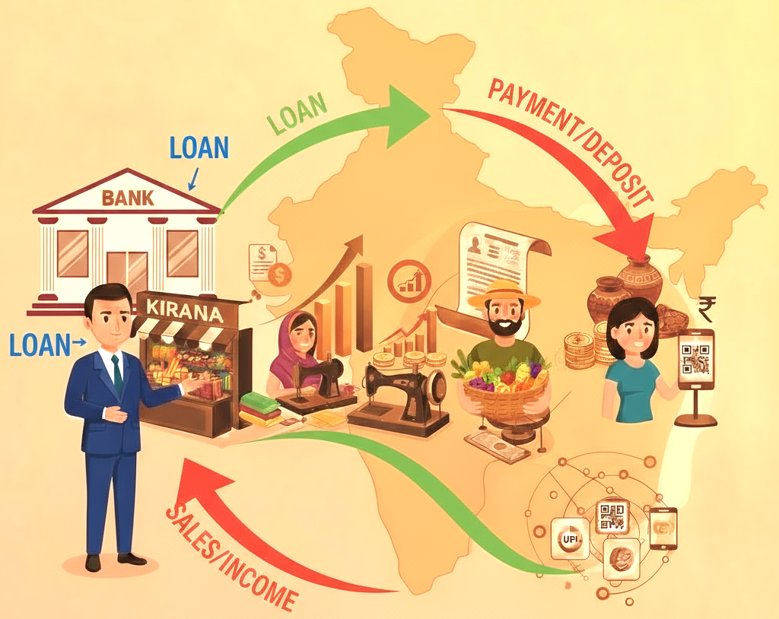
from 21st to 23rd April 2026
Open to Members & Non-Members
Individual participants can also register for the programme at their own cost
Program Co-Ordinators: Nayandeep Chatterjee; Rashmi Ranjan Rath
Mail Id: je.pdcgau1@iibf.org.in,head-pdcgau@iibf.org.in
Address: 3rd Floor, 3, Rani Sati Sadan, Motilal Nehru Road, Pan Bazar, Guwahati, Kamrup Metropolitan, Assam, 781001 | Website: www.iibf.org.in
BRIEF BACKGROUND
Established on 30th April 1928 as a company under Section 26 of the Indian Companies Act, 1913, the Indian Institute of Banking & Finance (IIBF), formerly known as the Indian Institute of Bankers (IIB), is a professional body of Banks, Financial Institutions, and their employees in India. IIBF during its 97 years of service been actively involved in examination, training & academics. It has emerged as a premier institute in banking and finance education.
Considering the emerging requirements of finance professionals in the ever-changing dynamic environment, IIBF has been providing quality training. The programs are designed in consultation with industry experts and human resources personnel with an endeavour to address the skill gaps on a continuous basis.
The regular offerings in varied areas prepare the finance professionals ahead of the impending change. IIBF has state-of-the-art training facilities at its Leadership Centre at Mumbai, and it has four Professional Development Canters (PDCs) at Mumbai, Delhi, Chennai, Kolkata & Guwahati catering to the increasing demand for the focused training programmes.

ABOUT THE PROGRAMME
Micro, Small and Medium Enterprises (MSMEs) form the backbone of India’s economic growth, contributing significantly to employment generation, exports, credit off-take, and industrial output. With evolving government policies, technological advancements, and dynamic market conditions, it is essential for banking professionals to stay updated with the latest developments in MSME financing and restructuring.

This 3-day training programme is designed to enhance the competency of officers involved in MSME lending, credit appraisal, monitoring, and restructuring. The sessions provide a comprehensive understanding of the MSME ecosystem, Government schemes, revised regulatory guidelines, appraisal tools, credit underwriting techniques, restructuring frameworks, and practical case studies.

The programme will be extremely helpful for participants to effectively finance the MSME sector, strengthen credit delivery, improve assessment quality, and support viable MSME units with informed decision-making.

Through expert-led discussions, hands-on exercises, and real-time case analysis, participants will gain practical insights to handle MSME credit proposals, mitigate risks, and enhance the overall MSME portfolio of their institution.

OBJECTIVES
The programme is designed with the following objectives:
- To provide a comprehensive understanding of the MSME sector, its revised classification norms, economic contribution, regulatory framework, and recent Government initiatives.
- To familiarise participants with key Government schemes.
- To strengthen skills in pre-sanction due diligence, including KYC, credit verification, digital credit tools, market checks, CIBIL/CMR evaluation, and borrower assessment using digital platforms.
- To enhance participants’ capability in analysing MSME financial statements, including CMA data, operating statements, ratio analysis, and key financial indicators.
- To equip bankers with technical skills in term loan appraisal, including TEV study, DCF, NPV, IRR, BEP and sensitivity analysis.
- To provide hands-on learning through practical exercises and case studies on term loans, working capital assessment, and credit structuring for MSMEs.
- To enable understanding of CGTMSE, CGSSD, CGECL norms, including practical aspects of claim lodgement, documentation, guarantee management, and settlement procedures.
- To build competency in MSME restructuring, covering RBI’s latest restructuring guidelines, methods, viability parameters, and practical case-based exercises.
- To develop the ability to monitor MSME accounts effectively, including SMA classification, Early Warning Signals (EWS), Red Flag Indicators, and dealing with non-cooperative borrowers.
- To empower participants to improve credit quality, mitigate risk, and support the growth and sustainability of the MSME sector through responsible and informed lending practices.
CONTENT OVERVIEW
The 3-day programme covers the following key areas in MSME financing and restructuring:
Day 1 – MSME Fundamentals & Credit Appraisal Basics
- Overview of the MSME sector, revised classification norms, and its contribution to the Indian economy.
- RBI regulatory guidelines and new Government initiatives supporting MSMEs.
- Key Government schemes
- Pre-sanction due diligence: KYC, borrower/guarantor verification, digital platforms, market enquiries, credit scores (CIBIL, CMR) and other scrutiny tools.
- Use of digital credit underwriting systems and technology-enabled due diligence.
- Analysis of financial statements, CMA data preparation, operating statements, ratio analysis and interpretation.
Day 2 – Term Loan Appraisal & Working Capital Assessment
- Term loan appraisal techniques: TEV study, DCF, NPV, IRR, BEP and sensitivity analysis.
- Practical case studies and exercises on term loan assessment.
- Working capital assessment: methods of assessment, projections, cash flow evaluation, and hands-on exercises.
- Practical application of working capital analysis using real-time case examples.
Day 3 – CGTMSE, Restructuring & Credit Monitoring
- CGTMSE, CGSSD, CGECL norms: eligibility, documentation, claim lodgement and settlement procedures.
- RBI’s latest guidelines on MSME restructuring, restructuring frameworks, viability assessment, and restructuring methodologies.
- Practical case studies and exercises related to restructuring of MSME advances.
- Credit monitoring and follow-up: SMA classification, Early Warning Signals (EWS), red flagging of accounts, identification of non-cooperative borrowers, and compliance-related aspects.
- Understanding Committee formation and key learnings from judicial references (e.g., M/S Pro Knits Judgment).
METHODOLOGY
- Live virtual interactive sessions on Zoom by senior faculty with expertise in MSME Finance, featuring case studies, presentations, and experience sharing. Participants can join from home or office using any device.
- Login details for accessing the sessions shall be shared on registered mail ids of participants 24 hours before the program.
- 75% attendance is compulsory for issuance of certificate.

TARGET GROUP
- Officers of Commercial Banks, RRBs, Co-operative Banks, SFBs, NBFCs and Financial Institutions.
- Branch Heads, Credit Officers, and staff handling retail MSME loans, Mudra loans, and small-ticket financing.
- Suitable for operational and mid-level officers involved in frontline MSME lending.
(Banks & FIs may send their nominations in bulk.)

DURATION
Days - from 21st to 23rd April 2026
Timings: 10.00 A.M. to 05.15 P.M. (First day session at 09.45 am)

FEES
₹ 7500/- plus GST @18% (₹ 1350/-) aggregating to ₹ 8850/- per participant
(In case of TDS deduction, please send us TDS certificate).

Programme fees may be remitted to the credit of Institute’s account as given below:
Beneficiary Name | : | Indian Institute of Banking and Finance
Name of the Bank Branch | : | State Bank of India, Pan bazar, Kamarpatty, Baptist Church Complex, Guwahati, Assam 781001
SB Account No | : | 44310223983
IFSC Code | : | SBIN0010756
PAN No.: AAATT3309D |  | GSTN No.: 18AAATT3309D1ZR
In case of any quires, kindly contact
Mr. Nayandeep Chatterjee
Junior Executive
je.pdcgau1@iibf.org.in
Mob : +91 7003787006

** Last Date of Registration is 19th April 2026 **
To register kindly email, us the following details

Sr. No. | Name  (as required on certificate) | Institution Name | Branch/  Office/Department | Designation | Mobile No.  (WhatsApp) | E-mail Id
1 | Ms.
2 | Mr.
Add additional rows as required

Institution Details
Name of Bank / FI | :
Address (where certificate is to be sent) | :
GST No. | :
PAN No. | :
Details of Nominating Official
Name | :
Designation | :
Mobile No. | :
E-Mail Id | :

